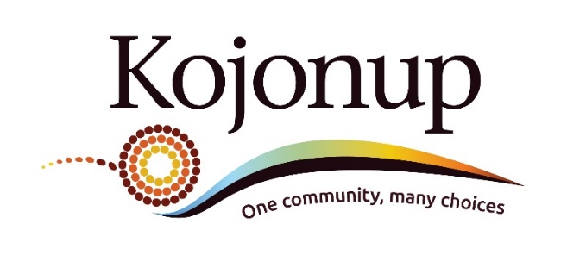
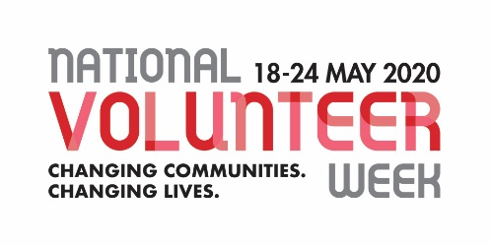
Volunteer Awards 2020
Do you know someone who gives up their valuable time volunteering for the benefit of others in the Kojonup community? Say “Thank you” by nominating them for the Shire of Kojonup’s Volunteer Award.

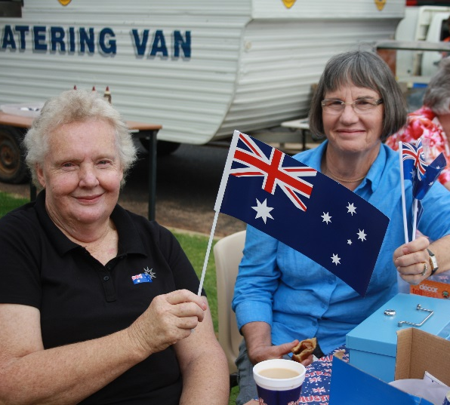
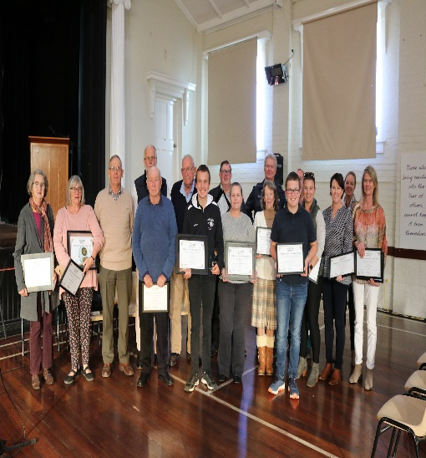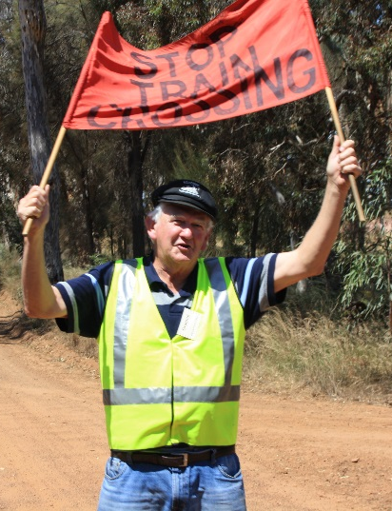

Award Categories:
For outstanding contribution to the local community
Volunteer of the Year (over 35 years)
Young Volunteer of the Year (under 35 years)
Community Event of the Year
Community Group of the Year
All Nominations close – Monday, 27 April 2020
Selection Criteria
Nominees will be assessed by a judging panel on two or more of the following criteria:
- The level of volunteering contribution
- Makes a significant positive contribution to the local community
- Demonstrates a strong local community focus
- Active member of the local community
- Level of contribution to the community
- Commitment to enhancing the local community
- Benefits to Kojonup
- For nominees school aged they need to have taken part in volunteering within the community, at their school or in other programs.

Eligibility Criteria
Recipients must be residents of the Shire of Kojonup or be members of a community group whose principal activities are conducted within the Shire of Kojonup and volunteered between April 2019 and March 2020.
Only one person (not a couple or group) may be nominated for individual categories.

Nomination Process
Anyone in the community can submit a nomination by completing the attached form. This will ask you to provide an explanation why the individual, group, or event is being recognised by you for the award. You can nominate yourself but you will need to provide a contact for a referee supporting your nomination and claim.
Nomination forms are available by downloading from the Shire of Kojonup’s website www.kojonup.wa.gov.au or picking up copies from the Shire office and library, the Kojonup Visitor Centre as well as various businesses in town.
Please complete and submit your form by:
EMAIL: cdo@kojonup.wa.gov.au
MAIL: Shire of Kojonup
Volunteer Awards
PO Box 163, Kojonup WA 6395
IN PERSON:
- Shire of Kojonup Office
- Kojonup Visitor Centre
- Dropped into the nomination boxes located
at various businesses around town

All Nominations close – Monday, 27 April 2020

Nominees and Award recipients will be announced at the Shire of Kojonup’s special Volunteer’s Award Ceremony on Sunday, 24 May 2020 being held at the Kojonup Memorial Hall.

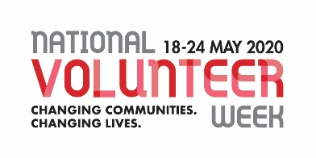
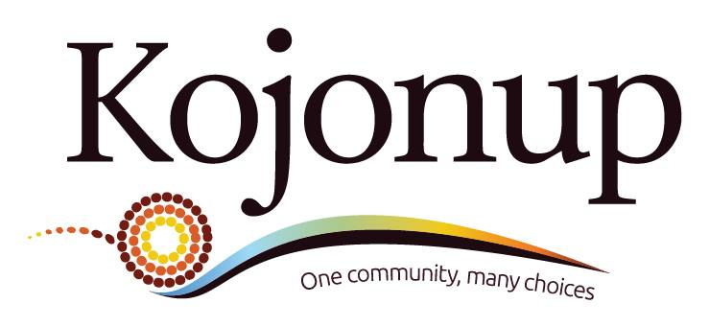

Volunteer and Young Volunteer of the Year
Nomination Form

As part of National Volunteer Week, 18 - 24 May 2020, the Kojonup Shire will be hosting an award ceremony to acknowledge and celebrate the commitment and contribution of local volunteers, community groups and community events to be held at the Memorial Hall on Sunday 24 May 2020.

Which local individuals and groups do you believe need to be nominated and recognised at this event?

Please tick the box below to indicate what category your nomination is for:

Volunteer of the year

This award will be presented to an individual who has worked tirelessly to benefit Kojonup. Locals nominated for this award must be over the age of 35 and have made an outstanding contribution to the community.

Young volunteer of the year

This award will be presented to a local individual, who may be a school student who has taken part in volunteering within the community (at their school or in other programs) or to any other individual aged 35 and under who has made an outstanding volunteering contribution to benefit the community of Kojonup.

Community Event of the year
This award will be given to a local event which has been held between May 2019 and March 2020 which demonstrated a strong local community focus and volunteering element.

Community Group of the year

This award will be given to a community group who has worked tirelessly to benefit Kojonup between May 2019 and March 2020. The group has to have demonstrated a strong local community focus and volunteering element.

Please complete all sections of the nomination form:

Nomination by (your name):

Phone:

Email address

Information about the person you’re nominating:

Name:

Phone:

Email address

Tell us about this individual’s volunteering achievements in our community:

Please nominate another worthy individual volunteer, group or event by using an extra nomination form available from the Shire of Kojonup website and all major stores and cafes in Kojonup.

ALL NOMINATIONS CLOSE Monday 27 April 2020

