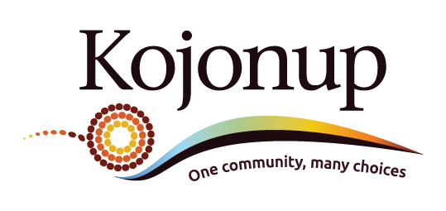

PUBLIC NOTICE
PROPOSAL OF LOCAL LAWS
Review of Local Laws – s. 3.12 (3) of the Local Government Act 1995
The Shire of Kojonup provides public notice in accordance with s. 3.12 (3) of the Local Government Act 1995 that it proposes to make the following local laws based on Western Australian Local Government Association model local laws:
- Parking Local Law 2022
Purpose: To enable better parking practices and to remedy parking anomalies in the Shire of Kojonup.
Effect: Effective and consistent parking practices within the Shire of Kojonup.

- Cats Local Law 2022
Purpose: To address the impounding of cats, requirements and limitations on the keeping of cats, and the requirements of approved kennel establishments within the Shire of Kojonup.
Effect: To provide for consistent and effective management of the cat population within the Shire of Kojonup.

A copy of the above laws can be obtained from the Shire of Kojonup Administration Office, 93 Albany Highway, Kojonup or by viewing them on the Shire of Kojonup’s website at www.kojonup.wa.gov.au
Submissions or comments regarding these proposals may be made in writing to the Chief Executive Officer, Shire of Kojonup, at the above address or in writing to PO Box 163, Kojonup, 6395 by 4.00pm Monday, 28th of February 2022.
Further information may be obtained by contacting the Manager of Regulatory Services on 9831 2424.

Grant Thompson
Chief Executive Officer

